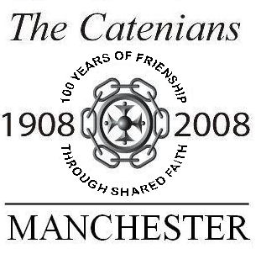
CATENIAN BROTHER’S ORDER FORM

Manchester Centenary Mementos Date……………………….

Dear Brothers, I am pleased to order the following items for delivery to my home address, as follows:-

Item Code | Item Description | Qty. | Unit Cost |  | Total Price
CW6R | Centenary Wine Red Shiraz x 6 bottles |  | £42.00 | *
CW6W | Centenary Wine White Viognier x 6 bottles |  | £42.00 | *
CW12M | Centenary Wine 8 Red/ 4 White x 12 bottles |  | £84.00 | *
CPSEL | Centenary Polo Shirt – Extra large |  | £13.00
CPSL | Centenary Polo Shirt - Large |  | £13.00
CPSM | Centenary Polo Shirt - Medium |  | £13.00
CPPS | Centenary Pen & Pencil set |  | £6.00
* | - delivery within UK only
 |  |  |  |  | £.

Name…………………………………….Prov No………. Circle………………. No……

Delivery address: …………………………………

…………………………………

………………………………… Post Code……………………………

Special delivery instructions. ……………………………………………………………………

Signed……………………………………

Your order is accepted on behalf of the
Manchester Conference Liaison Committee P1&17.
Enquiries to: Catenian Association. Tel: 024 7622 4533

Paid……….£ .00 by Cheque by Cash

Dated………………………………

Signed……………………………………Print Name……………………………………..
Official Steward

NB. Cheques to be made payable to: ‘ A Hillier 2008 CCMLLC’. Please send form and cheque to Bro John Ross, Abbey House, Chelford, Macclesfield, SK11 9AH

Catenian Centenary Celebration Wines

McLaren Vale Shiraz 2005

From a great vinery in South Australia, Shiraz is what they do best. Big and rich it has immense flavour and mouth feel and enjoys a long smooth finish. Absolute steal as the price of McLaren Vale has rocketed after a very low crop in 2007.

Vin de Pays Viognier 2005

This white comes from Domain Lalande just near Carcasonne in the South of France. A favourite white variety as it is full of confectionary aromas and has the mouth feel of a good chardonnay. Has good acidity to keep it fresh, which is also helped by being tank fermented and not barrel fermented.

Please see over for order form and price list to order these special Catenian wines
For delivery in the UK mainland only.
Enjoy them with your friends and Circle brothers!
Province 1&17 Manchester Conference Liaison Committee

